,

Moss Hey Primary School
Year Two Home Learning

We hope you enjoyed using ‘Seesaw’ last week. It was great to receive so many photos of the fantastic work you have been doing so make sure you keep sending them in!
If you haven’t used ‘Seesaw’ yet, just log in using your unique text code, check your ‘Inbox’ for any announcements and then click ‘Activities’ to retrieve the tasks for this week. Each week, we will provide feedback on one piece of work set through ‘Seesaw’ so don’t forget to upload a photo of what you have been doing!

This week’s feedback task will be:
Maths Activity : Choose a red, amber or green challenge

The theme this week is: Habitats- Why can’t a Meerkat live in the North Pole?


Spot the themed activities in the Home Learning grid!

You will find a selection of home learning activities for your child below. Evidence suggests that at primary school level there are two things which make the greatest difference to your attainment linked to home learning:

1. Reading regularly with an adult and discussing what you have read
2. Regular times table practice

English Tasks

English Tasks

English tasks this week are based around this book:
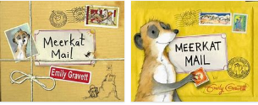
Sunny the meerkat lives with his enormous family in the Kalahari desert. They are all very close . . . so close, in fact, that one day Sunny decides he's had enough and packs his bags. He's off to visit his mongoose cousins. But from the watery world of the Marsh Mongoose to the nocturnal lifestyle of the Malagasy Mongoose, Sunny just doesn't fit in. And who's that shadowy figure who seems to be following him around? A brilliant picture book from the winner of the Kate Greenaway Medal.

- Watch the YouTube video- https://www.youtube.com/watch?v=_GUQt4VJ5DI
- I have included a powerpoint of the story with illustrations and text. Refer to file on the blog
- English activities for the week- refer to the blog for explanations and instructions. Hope you enjoy the activities this is one of favourite stories!

Reading:
- There is 1 reading comprehensions to choose from this week. Choose from Stage 1, 2 and 3. Stage 3 is quite tricky. Enjoy learning about different habitats.

Spelling/Grammar/Punctuation/Vocabulary:
Following on from the suffix task last week, have a go at completing the suffixes booklet.
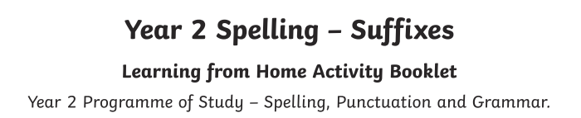

Maths Tasks



White Rose Maths https://whiterosemaths.com/homelearning/year-2/ The worksheets can now be found attached within the blog. Watch the daily video and complete the worksheet.
(Summer Term – Week 8: W/C 15th June – Shape)
FEEDBACK TASK- Solving mathematical problems and puzzles
There are maths tasks- RED, AMBER, GREEN. The challenge system we use in school.
Decided which challenge you would like to complete. Upload a photo of your work, including your workings out!
I look forward to seeing your responses. Happy problem solving!

BBC Bitesize - The BBC has put together daily maths lessons for children to access. Explore the maths lessons for Year 2. They link with White Rose Maths and have a daily TV programme too.

Mathletics

Well done to the children who have logged on to Mathletics and had a go at some of the challenges we have set. If you haven’t logged on yet, please prioritise this as one of your maths tasks for this week.

Theme Tasks
Science
Research questions:
What animals live in the desert and how do they survive?
Why do meerkats live in the desert?
What animals live in the North Pole and how do they survive?

Choose one, two or all of the questions to explore.
Present your information in any way you choose, a poster, factsheet, pictures with captions, drawing with captions, a video or a Powerpoint.
Reflect on the questions, what were your main findings.
I look forward to seeing what you find out and how you present your information. Happy research!

Wellbeing-
Continue to track you progress with these brain breaks- Let me know how you are doing with them!
At school we take Brain Breaks to re- focus and re- energise when we are working hard in the classroom. Try these 60 second Brain break challenges at home when you are doing your work. There is a challenge record sheet to track what you do!

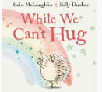
Following on from The Hedgehug activity I set in a previous Home Learning Grid, watch While We Can’t Hug, the sequel to The Hug.
-https://www.youtube.com/watch?v=2PnnFrPaRgY
Think carefully about the video and complete the task. (see attached file)

Ongoing Weekly Tasks
Decodable Phonic comics for applying phonic skills-www.phonicsplaycomics.co.uk/index.htlm

Letter and Sound daily lessonhttps://www.youtube.com/channel/UCP_FbjYUP_UtldV2K_-niWw/channels?view_as=public&fbclid=IwAR3oPhtObguFbJJJBem1RroKppgOhCYjkzT2QJHjbSxQ3QwbErApPKaEpz4

BBC Bitesize- They have released some great lessons with teachers that the children can access and follow through independently.
TT Rockstars- Online timestable practise.
Mathletics- You should have your login details from ClassDojo so login and complete some of the work set and play some games.
Oxford Owl – Online ebooks which match your child’s reading book band.
Classroom Secrets – Online activities that your child can access.
White Rose Maths- This is the scheme we follow in school and they continue to update it with activities that can be completed at home.
Spelling/phonics- related to your year group or what you are covering in school.
ICT Games – Interactive Maths and English games.
Once Upon a Picture – A selection of interesting images which can inspire your child to write. It could be a story, a recount, a set of instructions, whatever motivates your child.
Pobble 365 – Short daily writing tasks
Roy the Zebra – Interactive reading games.
Topmarks - A range of interactive activities for all subject areas throughout the curriculum.

